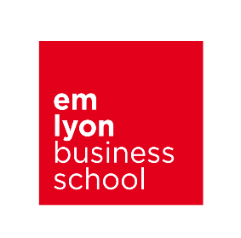
emlyon business school – EMBA

Project Request Form
EMBA Individual Makers Projects 2021

Please take some time to complete this request form. It will be used to communicate your needs to our EMBAs who start to look for consulting projects from February 2021 onwards.

Send this Request Form to Nelly Rousson ideally before March 15, 2021 but not later than May 15, 2021 (nrousson@em-lyon.com).

Project Title | Be as specific as possible
Company | Name, type of activity, turnover, number of employees….
Contact person (name, title, phone, email)
Project language requirement | English or French or both:
Brief description of the project  (General context of the project, objectives, key deliverables) | (An EMBA consulting project typically involves 1 participant, for a total of about 300 hours over the duration of the project from February to November, delivering significant value to sponsoring companies. What outcome and value is the company seeking?)  General Context:  Problem or opportunity:  Objectives of the project:  Key Deliverables:  Expected benefits:
Unique benefits, learning and value for the participant | (The EMBA consulting project is a learning experience. In return for their work and investment, participants expect to learn and discover something unique or valuable; what is that for this project?)
Special Requirements  (skills, knowledge, other requirements) | (What specific skills or knowledge or other requirements do you desire or require for this project?)

