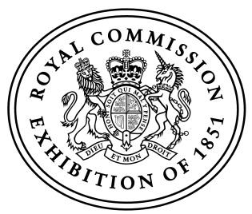

BBC World Service and The Royal Commission
for the Exhibition of 1851 present

The Engineers: Intelligent Machines

Intelligent machines are remaking our world. The speed of their improvement is accelerating fast and every day there are more things they can do better than us. Already a computer can defeat the world’s greatest human player at our most complex game, the first movie written by AI has just been released, and artificial intelligence is making some major break-throughs in medicine. There are risks, but the opportunities for human society are enormous. How have intelligent machines made such innovations in such a short time? What are the limits to what AI can do?

The BBC World Service and the Royal Commission for the Exhibition of 1851 have joined forces to hear from the leading engineers in this field. In a special public event, recorded live for the BBC World Service at the Great Hall of Imperial College, Kevin Fong will present The Engineers: Intelligent Machines.

‘Machine Learning: AI’ is the technological revolution of our era. The programme will feature three engineers at the forefront of that revolution -

- Regina Barzilay, Distinguished Professor for AI and Health at MIT. She created a major breakthrough in detecting early stage breast cancer. She also led the team that used machine learning to discover Halicin, the first new antibiotic in 30 years.

- David Silver, Principal Scientist at Google DeepMind. He led the AlphaGo team that built the AI to defeat the world’s best human player of Go.

- Paolo Pirjinian CEO and founder of Embodied. He is a pioneer in developing emotionally intelligent robots to aid child development.

The Engineers is an annual event staged by the BBC World Service in partnership with the Royal Commission for the Exhibition of 1851. The producer for the BBC is Charlie Taylor.

The event will take place at the Great Hall of Imperial College, London, at 6.30pm (BST) on Tuesday 23 July.

To join us as part of the audience, tickets are free and will be available on the BBC Audiences site here: https://www.bbc.co.uk/showsandtours/shows

The recording of the event will broadcast on 10 August at a time to be confirmed on BBC World Service and will be available on BBC Sounds.

ABOUT BBC WORLD SERVICE

The BBC is the world’s most trusted international news broadcaster – committed to providing accurate, impartial, and independent news to audiences around the world. The BBC World Service is the BBC’s international broadcaster, delivering a wide range of programmes and services on radio, TV, and digitally. It reaches a weekly audience of around 318 million people each week (BBC Global Audience Measure 2023) and operates in 42 languages, including English.

ABOUT THE ROYAL COMMISSION FOR THE EXHIBITION OF 1851

The Royal Commission for the Exhibition of 1851 offers major awards to scientists and engineers for research, development and design. First established to stage the Great Exhibition in 1851, the Royal Commission's extraordinary history is founded on an inspired vision of the importance of education to economic success. It has previously funded luminaries such as Nobel laureates Professor Peter Higgs, Sir James Chadwick and Paul Dirac.

