

How has a bad event changed your life?

Information about the project

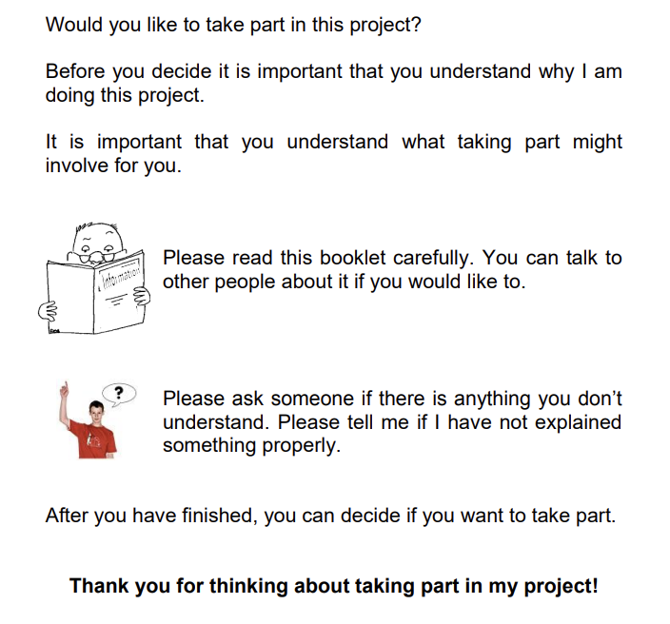
This project is about how people with learning disabilities cope after a bad event
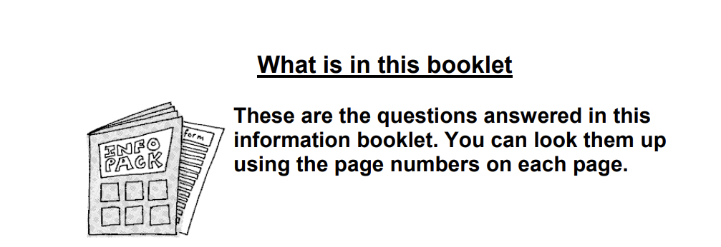

What is the project about? – pg 3

Why do you want me to take part? – pg 4

Do I have to take part? – pg 4

What will happen to me if I take part? – pg 5

What do you want to ask me? – pg 6

Will I be recorded? – pg 7

Will taking part be good or bad for me? – pg 8

Will you tell people what I say? – pg 8

What will you do with that you find out? – pg 9

Contact information – pg 9

What is the project about?
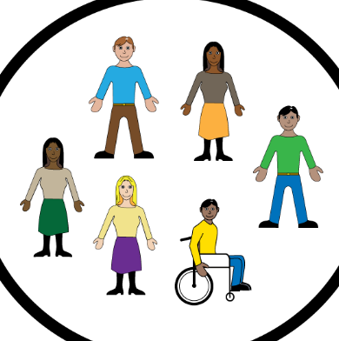 | I want to find out about how bad events can change the lives of people with learning disabilities
 | Bad events could be:  - People being nasty to you  - People hurting you  - People forcing you to do things you did not want to do  - Seeing something awful  - Losing someone or something close to you
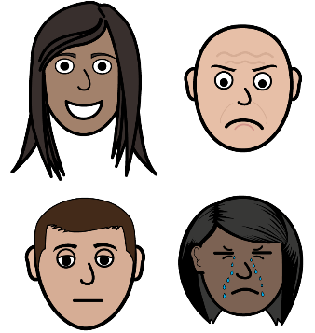 | These bad events may have made you feel sad, scared, or angry.  Over time you may have noticed more positive changes as well.
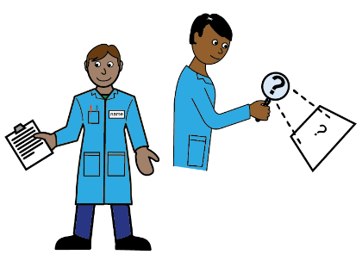 | I am doing this project because I am a research student.
Why do you want me to take part?
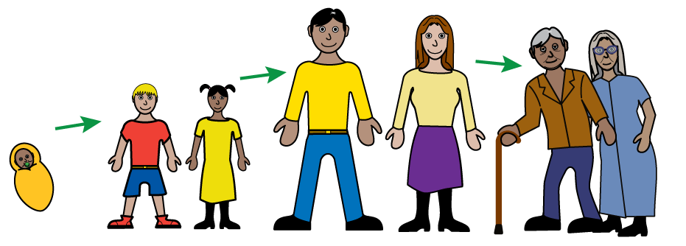 | I am trying to find out how bad events change people’s lives.
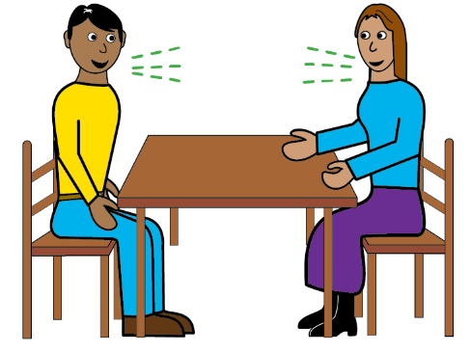 | This means interviewing people who have experienced a bad event to get to know what they think.
Do I have to take part?
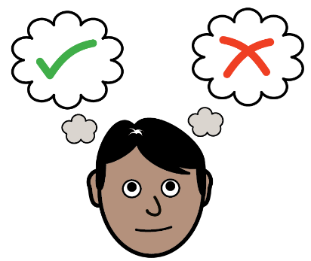 | It is up to you if you want to take part.
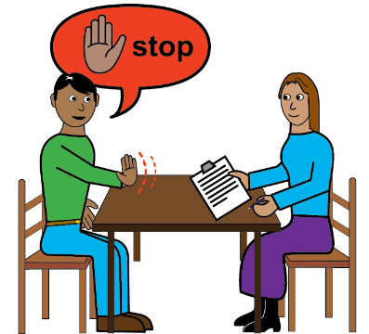 | You do not have to take part or answer any questions you don’t want to
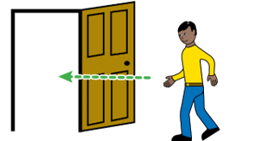 | You are allowed to leave at any time in the interview.
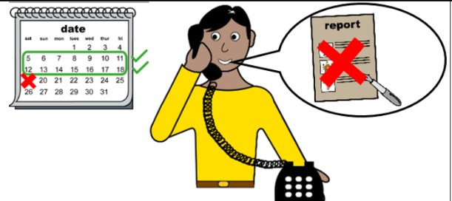 | If you take part and change your mind later, you have two weeks after the interview to ask to be removed from the study.
What will happen to me if I take part?
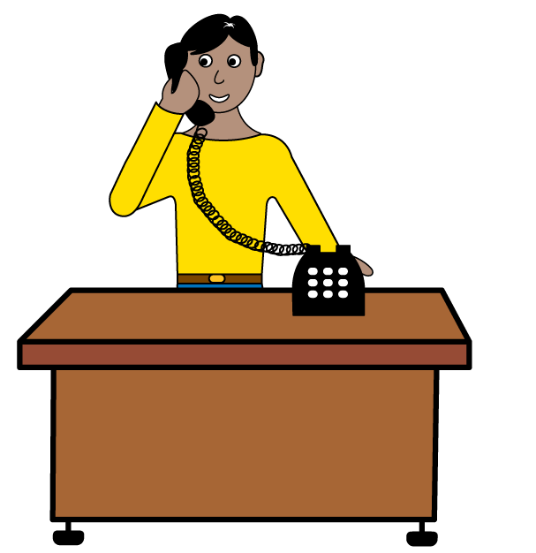 | I would call you on the phone to talk about the project with you and set up a interview.
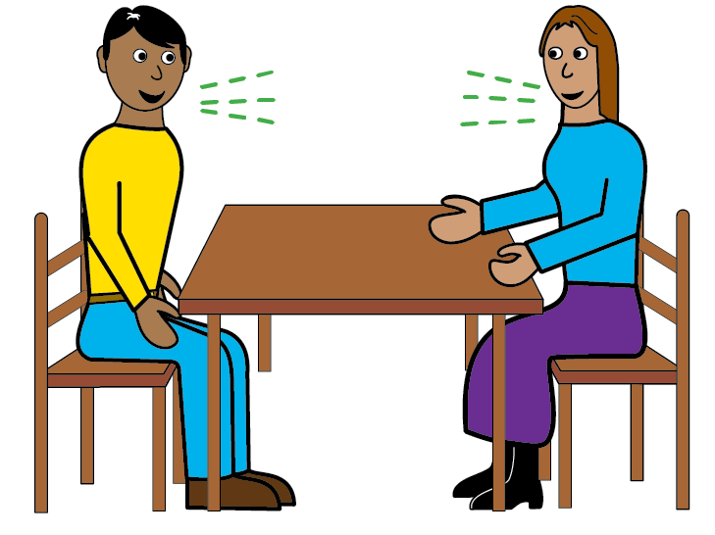 | We would then meet up and talk about whether you are happy participating in the study and about how life have changed for you because of a bad event.
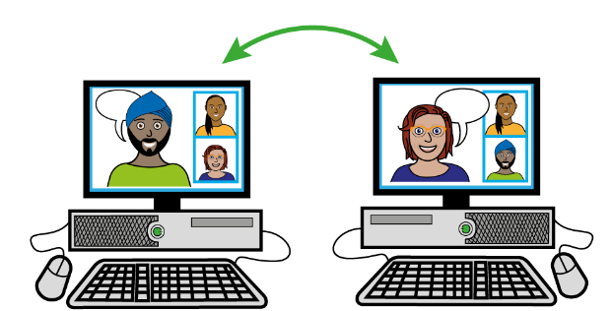 | If you have to travel a long way, then we can talk online instead
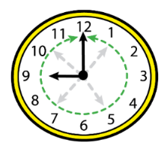 | The interview will last about an hour
What will you ask me?
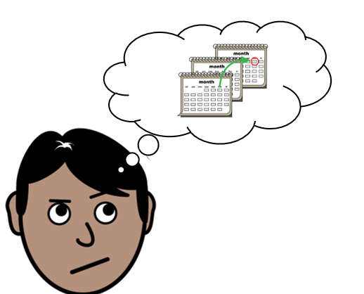  PAST | I will ask you about how your life was before the bad event.
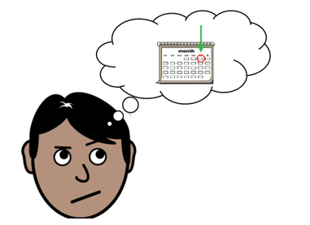  NOW | I will then ask you how your life is now and whether you think your life has changed
Will I be recorded?
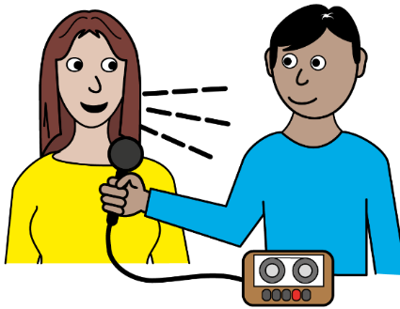 | Yes.  The interview will be recorded
 | I will only use the recording to help me write up what you have told me.  I will keep the recording stored safely on a computer system which is protected by a password
Will taking part be good or bad for me?
Some bad things about taking part are:
- It will use some of your time
- You may get sad when talking about a bad event.
 | Some good things about taking part are:  - You will have the chance to tell me about your life  - You will help me improve support for people with learning disabilities  - You will get a £25 voucher
Will you tell people what I say?
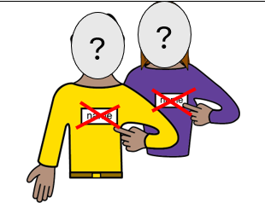 | Your name will be confidential.  This means other people will not know what you told me.
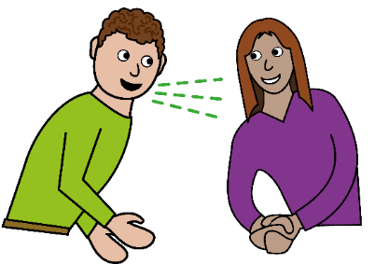 | But if I was worried about your safety or the safety of others, I will have to tell someone else.
What will you do with what you find out?
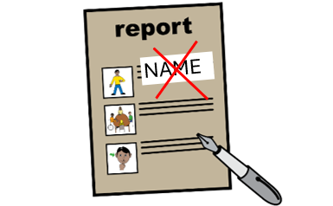 | I will write a report so people can read what I found out.  Your name will not be in it.
Contact information
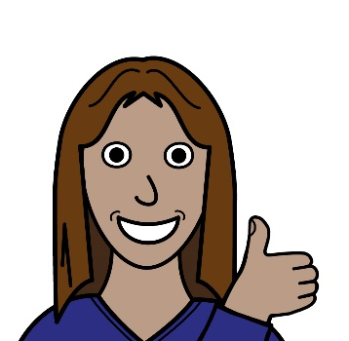 | If you want to take part in the project or please contact me by
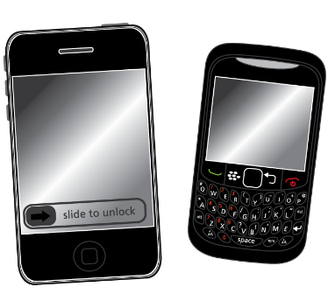 | Phone or text  07858029031
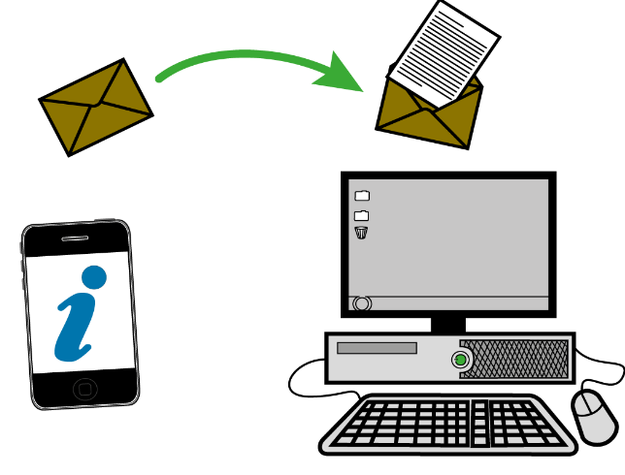 | Email  Umly@leeds.ac.uk

