CYP ASD Assessment Pathway Information for CYP, Families, Carers, Referrers and Professionals

Aim of the information:
This information is to inform parents/carers, older young people, referrers, and professionals. The aim is to ensure that everyone who may be involved in the process understands what autism or neurodivergence is, how it can present in children and young people, how a referral is made, what early support is available while waiting and after diagnosis, and what the assessment process entails.
Where will the information be available from?
This information will be shared in two formats. The main body of information will be included on the Bromley Healthcare webpages. They are the provider of the assessment service. There will be multiple links to and from this webpage including the Bromley Local Offer which sets out the local offer for families who need support.
There will be in addition, a leaflet which includes a summary of this information. This will be in paper and electronic form. The leaflet will be made available to GPs, schools, and other CYP settings that may need to understand the process and keep families informed of choices.
How is the information being designed?
We are seeking the views of a number of partners in health and social care, plus from people who have lived experience of the pathway or living with autism. All views will contribute to the co-production of information that is accurate and useful.
The following is a draft of the types of information shared and the wording we may use. We are seeking feedback on this and welcome comments and ideas on how to improve this content before we publish it in late summer/ early autumn.
Each box you see below will be a tab on the website with then links to tap on to reach each section. Feedback on this format is also very welcome.

Page or tab on website: The assessment process
Each new box will be accessed via clicking on a link.
Title | Content | Your comments
The Autism Assessment Pathway in summary | 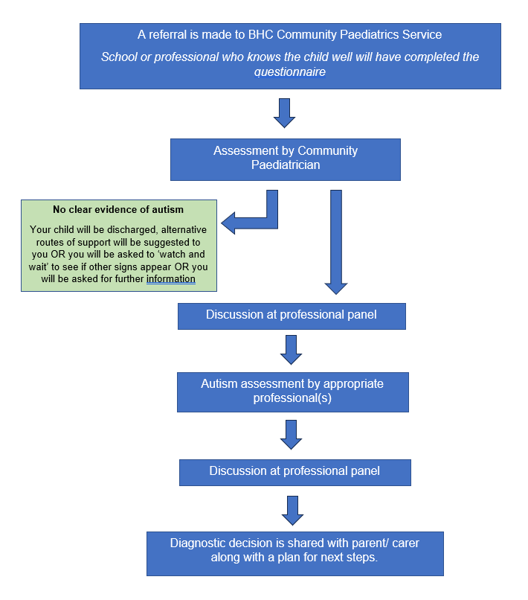  This flowchart is a summary of the autism assessment pathway for children and young people. You can read about each stage in more detail.  Families can get support and help at any point during this process. The professionals involved in your journey, or the information provided here can show you what support is available and how to access it.
Step 1: Referral | Community Paediatrics (or sometimes written as CommPaeds) is the single-entry point for all children and young people’s referrals where there are concerns about neurodevelopmental disorder such as autism. The team accept referrals for children from any professional or person who knows your child well e.g., teacher, SENCO, therapist, childminder, day nursery or school nursery. If you have raised concerns with your GP then they will advise you to discuss a referral with your child’s school, early years setting, or health visitor. The referral must be made by someone who knows your child as they will be asked to complete a questionnaire.  Once the referral has been received and all information has been shared, an appointment will be made with a Community Paediatrician for an assessment of your child’s overall health and wellbeing. This step is important for children who may have other causes for their non-typical behaviours.  The person who made the referral will be able to help you understand access early support while you wait.
Step 2: Community Paediatrician assessment | At the Community Paediatric assessment, the doctor will take a detailed history of your concerns. This will include current problems, past medical history, birth history, family and social history, history of any allergies, vaccination status, any medications etc. Following talking to you, we will usually do a clinical examination of your child.  The doctor will consider the information provided by professionals (schools, pre-school setting therapist etc) in the questionnaire they have been sent. These questionnaires will help gather the full picture of your child’s behaviours – this will include their preferences, and strengths, , when they happen, and how often they occur.  Where the information suggests this could be autism then the community paediatrician will share the details of your child’s history with the Complex Communication Diagnostic Service (CCDS) panel.  If the information does not suggest autism, then the paediatrician will discuss this with you. They may suggest a period of ‘watch and wait’. This means that more information over time will be helpful to see if this is autism.
Step 3: The Complex Communication Diagnostic (CCDS) panel | Once the Community Paediatrician assessment is complete, and autism is suspected, a skilled team of people will meet for a clinical case discussion. This is known as a multidisciplinary team or an MDT. They meet as a specialist panel of professionals known as the CCDS. This usually includes the community paediatrician, a therapist, and a clinical psychologist. They will use all the information provided in the questionnaires, and the findings from the general assessment completed by the paediatrician. The potential outcomes following this process are:  - The CCDS will advise that an assessment for autism is not clinically indicated at this time, and they will share this information with your referring professionals – they will suggest alternative services or offer written advice. Further referrals can be made, and the team can reconsider cases if more information is provided.  OR  - The CCDS will ask for further information which may include a discussion with you, and then the panel will meet to consider the case again.  OR  - The CCDS will confirm that the information suggests an assessment for autism would be clinically indicated and will suggest a neurodevelopmental assessment with either a therapist or a clinical psychologist. If the circumstances are particularly complex, for example if your child has other conditions for example epilepsy or ADHD, then the community paediatrician may assess your child again.
Step 4: Neurodevelopmental assessment | Neurodevelopment assessment is performed by either a therapist or a clinical psychologist. In some cases, the community paediatrician may also perform a second detailed assessment. The Autism Diagnostic Observation Schedule, or ADOS for short, is one of the assessment tools we use as part of the overall Autism assessment process. It is an assessment that can be used with people of all ages, abilities, and language skills. It is a semi-structured, standardised assessment of communication, social skills, play and other behaviours. It enables us to look at how your child or young person communicates, how they interact with us, how they play and their ability to be creative, and also if they have any restricted or repetitive behaviours or interests. The assessment will also consider masking or common signs in girls which can be different from other children with autism.  During the assessment the clinician will play some games with younger children or carry out activities including questions about school, friendships and feelings with older children or young people. By watching the way your child communicates, interacts, plays, and behaves during the games and activities it helps us to understand if there are signs of autism.
Step 5: The assessment outcome | After the neurodevelopment assessment(s), the multidisciplinary panel will liaise to look at the information gathered throughout the process. A consensus decision will be made on a diagnosis.  You will be offered a feedback meeting to discuss the diagnosis and next steps.
Social story | This is yet to be completed – an example of how this can look can be seen through the link provided.  Example here - Rotherham-CAMHS-A5-family-leaflet-06.20.pdf (rdash.nhs.uk)
Preparing for the assessment | There are some things you can do to help your and your child prepare for the assessment. These actions may make you feel more prepared to provide information about your child, and to advocate for your child. Where a child is prepared they can feel more safe and included.  These actions can include:  - Think about your child’s development and what information may be helpful. These are examples:  Attitude towards structure, routine, repetition and sameness:  - Do they thrive with routine and structure?  - Any needs for sameness?  - Anxiety or reaction to uncertainty or change?  - Do they move their body in a repetitive manner?  Sensory experiences and preferences:  - What is their experience of the sensory world?  - Do they notice smells, textures or noises that others don;’t?  - Sensory experiences that are upsetting  - Sensory seeking behaviours, for example listening to the same song over and over, tapping, or rocking.  Co-ordination and motor skills:  - What are their gross motor skills like? For example balnacing, riding a bike, are they clumsy?  - What are their fine motor skills like? For example, writing buttoning up clothes, tying shoes.  Areas of passion or expertise:  - Special interests  - Ability to hyper-focus for a long time on one thing  - Excellent memory and knowledge of a particular subject  - Difficulty engaging in other subjects or topics.  Behaviour:  - Do you have any major concerns/ worries in this area?  - How do they express their distress or anxiety?  - Do they have meltdowns/ shutdowns?  - How are you currently managing this behaviour?  Strengths and appreciation:  - What do you appreciate about them?  - What are their strengths?  Developmental history:  - Pregnancy and birth  - Major developmental milestones, e.g. walking  - Developmental delays? e.g.speech and language  - Family history of autism, learning disability, mental health problems.  Home:  - Self-care skills (washing, dressing, eating)  - Safety skills (road, kitchen)  - Support needs and any difficulties.  School:  - What is school like for them generally?  - Grades, prgressd and learning abilities  - Reading and writing  - Additonal support in place  - Ability to ask for help  - Favourite and least favourite subjects  - Attention levels.  Relationships:  - How are things socially? Do they have friends and relationships?  - Do they have other relationships like pets or family?  - What is their play style e.g. creativity, repetitive play like lining up toys.  Mental and physical health:  - How is their physical health?  - How is their mental health?  - Any anxiety, low mood, meltdowns?  - What behaviours do they use to communicate distress?  Social communication preferences:  - How is their eye contact?  - What is their communication style, for example answering direct questions, information dumping, do they enjoy back and forth conversation?  - It is helpful for young people to know why they are being assessed.  If children do not know what is happening or why they can feel scared or think that something is wrong with them. It is important that they know this is not the case. It is helpful for your child’s self-esteem, anxiety and sense of autonomy to know about the assessment process before they take part.  Starting the conversation may sound something like:  “Ive noticed you are working really hard at school this year, but it seems like things might be tricky sometimes…I’m thinking that if we know more about how your barin works, your teachers and I could do a better job at helping you. We are going to meet someone who is going to help us learn all about how your brain works so that:  - Teachers know how to teach you  - Our family knows how to support you  - You can understand yourself better  - You can know how to explain what help you need better  - You can learn about the things you are great at.  Describing the process:  Although some children’s journerys will be different, most children will ahev one or more conversations with a professional. These meetings might involve:  - Talking about feelings, preferences and challenges at home, with friends, or at school.  - Playing some games and puzzles (some might be easy and some might be hard).
Waiting times | The waiting times can differ because of the needs for some groups of children to have different types of assessment by different professionals. Although we aim to keep waiting times as standard for everyone as possible this is not always the case. The approximate time you will wait will be shared on your letter. Please be aware you may wait for a shorter or longer time than indicated.  Your letter will include options for support available to you. Please ensure you take advantage of all the support available to you while you wait. You do not need a diagnosis to access this, and it can be beneficial for your child and for you as a family.
Next steps | A virtual feedback meeting will include a member of the assessment team, the family, and a member of the school where possible. If you would prefer a face-to-face feedback meeting, contact the assessment team who may be able to meet your individual needs.  You will receive a written letter with details of the findings from the assessment and what next steps might look like for you.

Page or tab on website: Early help and support
Each new box will be accessed via clicking on a link.
Title | Content | Your comments
Support services | We recognise that as families wait for the assessment process they need more immediate support – that is support that meets their needs and is not restricted to a diagnosis. This section provides links to accessing support that is right for you. Don’t delay in exploring these options as early support is shown to make a positive difference to children, young people, and their families.  Social Communication Needs (SCN) family support service  The Social Communication (including Autism) Needs Targeted Support Co-ordinator was introduced to provide information and advice to parents and carers of children with social communication needs. This service is referred to as ‘SCAN’ and helps parents and carers to navigate the support options and coordinate services available in Bromley and nationally.  Bromley recognises that not all families will require the same support and services. There is a lot of information, and this is where the SCAN service can help. The SCAN service will inform families of the accessible and supportive universal, targeted, and specialist provision available so that families can feel supported at home, in education, and in their community.  The ‘Social Communication Needs – next steps guide’ flipbook is a guide to the services available to you in Bromley, and provides answers to some common questions. It includes up to date information in a simple format that is easy to use.  The SCAN Service is the single point of access to Bromley’s specialist provision for those families for who may require additional intensive support for short periods at various points in their child’s developmental journey.  A SCAN referral form is available to access this support.  More information about social educational needs can be found at: https://www.bromley.gov.uk/homepage/187/social-and-communication-needs-including-autism  The Bromley Local Offer  The Bromley SEND Local Offer helps children and young people with special educational needs and/or disabilities and their families to find the information and support they are looking for from across Bromley in one place. These pages are designed to be clear, easy to access and have all the information you need to understand what is available to children and young people (from 0 - 25 years) to help to support their educational, health and social care needs in Bromley. The site also signposts families to other local organisations, initiatives and activities that might be of interest or help.  Local guide for families with autism  The Do you know…? guide has been pulled together by parents, carers, and professionals across the local area as part of Bromley’s all-age Autism Partnership (BAAP). It provides information and signposts families, carers, and those with social communication needs (SCN) including Autism to support. The guide is for families with children and teenagers who have social and communication difficulties including autism and it can be found at: https://www.bromley.gov.uk/downloads/file/2299/do-you-know-social-communication-and-autism-guide  Support from your school or education setting  Your school (including pre-school and college settings) will be able to help you refer your child for an autism assessment where there are social communication needs. They will be required to complete a questionnaire on your child. This will give the assessment team the information they need to make a full and effective assessment of your child.  The school can also provide support for your child to meet their needs. This can vary but can include adaptations to teaching methods such as being clearer with instructions, using visual aids for teaching, or having one to one support from a teaching assistant. Or they can use interventions such as reward systems or links to personal interests. The level of support can be that which is open to all children at school, or it may be more targeted through the Specialist Educational Needs or Disabilities (SEND) approach.  Most children and young people with special educational needs or disabilities (SEND) will have their needs met from within an education setting’s own resources. A small number of pupils will need additional support beyond what the setting would normally be expected to provide – in which case they may be eligible for an EHC plan. An EHC plan is a legal document that describes a pupil's special educational, health and social care needs and the support they need to help them to get the best outcomes when they become adults.  To decide whether an EHC plan is necessary, the pupil will need to undergo an EHC needs assessment. The EHC needs assessment is not normally the first step in the process for helping to meet the needs of the child or young person but should be built on co-ordinated work that is already happening between families, educational settings and any other health or social care services who are involved.

Page or tab on website: Understanding autism and it’s signs
Each new box will be accessed via clicking on a link.
Title | Content | Your comments
Explaining terms | Social communication refers to the use of verbal (spoken language) and non-verbal (eye gaze, facial expression, gestures) communication in social situations, to tell people what you want, express feelings, relate to other people and develop meaningful relationships (NHS definition). We use social communication needs as a broad term that covers autism, ADHD and any other diagnosed or undiagnosed need.  Social communication needs such as autism and ADHD are classed as neurodivergence. We understand that neurodivergence is just a difference and doesn’t need treatment but empathy and understanding.  The term neurodiversity describes differences in the way people's brains work. The idea is that there's no “correct” way for the brain to work. Instead, there is a wide range of ways that people perceive and respond to the world, with varying strengths and weaknesses. The terms neurodivergent and neurodivergence are now used to describe all people whose neurological conditions mean they do not consider themselves to be neurotypical.  There are a number of ways for being neurodivergent. They often overlap, meaning many people experience more than one type of neurodivergence. Here are some examples.  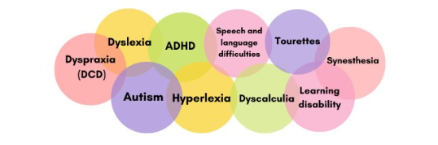  It is important for your child to know that there is nothing wrong with them, and that the purpose of these assessments is to understand how their brain works, so that they can learn about themselves and get the support they need to thrive.  You may find it helpful to explain your child’s or your own behaviour using these terms.
Age specific signs in the early years | Early Years – Below 5 years of age:  The following may be signs of autism in an early years child though there can be other reasons for this behaviour and these signs can vary significantly depending on the age of your child. Your health visitor will be able to help you when you are worried about these behaviours. Potential signs include:  - Language delay or changes for example, not yet talking like other children of the same age, difficulty in understanding your simple spoken instructions.  - Challenges in social relationships, for example, this may be lack of response to name calling, lack of responsive smiling or rejecting cuddles.  - Lack of or change in developing relationships. For early years this may be no or little copying of others, no or little social interest in others, no or little awareness of personal space, not showing enjoyment.  - Differences in non-verbal communication. For early years this may be little or no eye contact, difficulties in getting and holding their attention, a lack of normal face or body gestures like smiling, nodding.  - No or little imagination and no variety of pretend play. They may have the same repetitive play that they prefer over and over.  - Unusual or repetitive behaviours. For early years this may be hand flapping, body rocking.  - Over or under reaction to sounds, smells, taste, and textures. The child may get very upset or sensitive with certain foods, smells, or clothing.  These potential signs are usually persistent (they don’t change or go away) and are likely to be seen across multiple settings, for example with grandparents or in an early years setting. Not all these signs must be present to indicate autism. For example, some autistic children can maintain socially appropriate eye contact.
Age specific signs in school-aged children | School aged children – Aged 5 years and over  The following may be signs of autism in school-aged children though there can be other reasons for this behaviour and these signs can vary significantly depending on the age of your child and their circumstances. Potential signs include:  - not seeming to understand what others are thinking or feeling  - unusual speech, such as repeating phrases and talking ‘at’ others  - liking a strict daily routine and getting very upset if it changes  - having a very keen interest in certain subjects or activities  - getting very upset if you ask them to do something  - finding it hard to make friends or preferring to be on their own  - taking things very literally – for example, they may not understand phrases like "break a leg"  - finding it hard to say how they feel.  These potential signs are usually persistent (they don’t change or go away) and are likely to be seen across multiple settings, for example with grandparents or in school. Not all these signs must be present to indicate autism. For example, some autistic children can maintain socially appropriate eye contact.  It is important to be aware of potential masking, or of the differences in how girls can present. See the individual sections for the details of how to recognise these signs.
Masking signs of autism | For some children it is important to be aware of masking. This refers to an autistic person’s ability to try and minimise or mask autistic traits from others. Not all autistic people mask, but those who do may not always be aware they are engaging in masking behaviour. Some may struggle not to engage in masking even when consciously trying. It is worth noting that masking may interfere with an autistic person’s ability to communicate their needs with families or professionals. Therefore, a diagnosis can be more difficult to make.
Presentation in girls | Autism signs can sometimes be different in girls and boys. Autistic girls may:  - hide some signs of autism by copying how other children behave and play  - withdraw in situations they find difficult  - appear to cope better with social situations  - show fewer signs of repetitive behaviours  This means autism can be harder to spot in girls.  A fuller list of signs which may be helpful is available here: Autism in Girls Checklist

Page or tab on website: Information for young people
Each new box will be accessed via clicking on a link.
Title | Content | Your comments
Adult services | The children and young people assessment pathway for autism include young people up to the age of 18. After the 18th birthday then a person will be appropriate (in most cases, people with a learning disability may be an exception) for adult assessment services.  If your assessment is not yet completed but you are nearing the age of 18, or you have your 18th birthday while waiting, you will still be seen for your assessment.
Age-appropriate support signposting | If you are over the age of 14, you can access Bromley Well or Bromley MENCAP for support with:  - Social and leisure activities  - Health matters  - Managing your money  - Housing  - Transition into adulthood  - Managing letters, forms, and applications  - Support with employment  - Life skills training  - Signposting to further services.

Please add any other comments you wish to make here:

Thank you for your feedback.

