Workplace Adjustments Passport V.01

- Dissemination permission:
(amend as appropriate)
Brief to team colleagues as needed, disseminate written passport only to HR and line manager
Meet with employee and discuss before disseminating or briefing to any new people

- Condition(s)/Disability(ies)/Difference(s)
(amend as appropriate):
Autistic Spectrum Condition

- Preferred language:
(amend as appropriate)
autistic person, autistic

- Relevant Individuals
Employee Name:
Manager:
HR Contact:

- SUMMARY TABLE
It helps me when people | I have difficulty when people
- Redirect me when I’m off topic  - Follow up important points via email  - Communicate in a clear, literal and direct way to avoid misunderstandings  - Give clear timelines for things to happen, and updates as soon as possible if things are going off track  - Give me extra personal space | - Display ‘high-arousal’ communication, speaking very quickly and with quickly changing tone, volume and pitch of voice, fidgeting, lots of subtle micro-expressions  - Have noisy backgrounds whilst meeting remotely  - Mis-read me based on non-autistic communication and interaction  - Don’t give advance information of the purpose of a meeting or how I’m expected to contribute

- Strengths:
- Technology/Spreadsheets/Organisation/follow-up/admin
- Problem-solving/consultancy/reasonable adjustments for service users
- Detailed work
- Remembering written information
- Research (with strict time limits and purpose)
- Challenges:

- Anxiety – specifically time anxiety, and a tendency to overthink past social interactions
- Travelling on public transport, and not coping with noise, smells or people being to close, or travelling with other colleagues and feeling overwhelmed trying to coordinate with others
- Personal boundary/touch –I find it especially uncomfortable if people touch me to comfort me when I am anxious or upset, it often results in feelings of rage unless I am extremely comfortable and trust the person (this is rare)
- Noise sensitivity, especially ‘human’ noise
- Photo-sensitivity – prolonged strip/fluorescent lighting is painful
- Very sensitive to temperatures and am usually too hot
- I need a greater level of detail and information to cope with the unfamiliar
- I’m very open and don’t always filter topics that may not be expected
- I prefer written/visual communication wherever possible
- I often need to document to process important verbal information at a later date
- I’m chatty and can digress easily
- I try to join in with banter but don’t always get it right

- Agreed Workplace Adjustments
WORKPLACE ADJUSTMENTS

Collaboration and tasking | Advance, written notice of meetings wherever possible, with a written agenda/structure supplied to allow for preparation – specifically catch-up meetings, and feedback meetings or work planning and tasking
Sensory (tactile) | Extended personal space and no touching when in-person
Team meetings | For in-person meetings, a seat near the door so I can step out or stand up and move when feeling overwhelmed, seating set back from crowded meeting tables
Travelling | Additional time to plan and prepare, able to choose own accommodation for overnight stays, travelling alone, and by car wherever possible
Working arrangements | Designated home worker – travelling to quarterly team away days and in-person meetings if energy levels allow

Review date:
Next planned review date:
Review date:
Next planned review date:
Review date:
Next planned review date:
Review date:
Next planned review date:
Review date:
Next planned review date:
Review date:
Next planned review date:
Review date:
Next planned review date:
Review date:
Next planned review date:
Review date:
Next planned review date:

General Guidance notes
Passport structure
This passport has been designed in 3 pages
- The first page is a summary of the key information about a person, omitting any sensitive details such as mental health difficulties or very personal insights into the person’s differences.

- The second page includes more sensitive, nuanced and detailed formal information about the employee’s challenges and agreed workplace adjustments.

- The third page, which may be continued, documents the dates that the passport has been reviewed on and when future review dates are planned.

Reasonable adjustments process
A basic overview of the adjustments process is shown below.
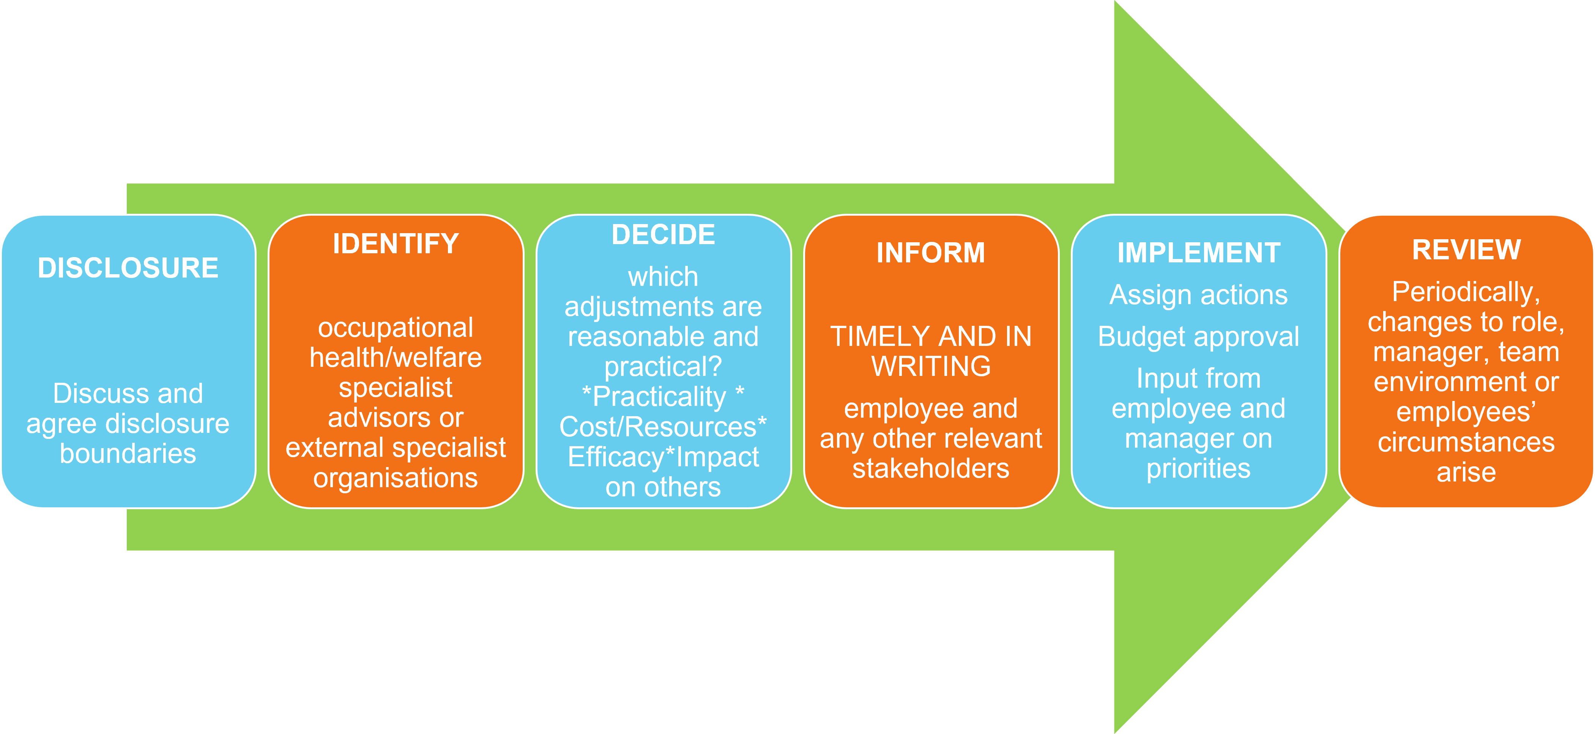

Talking about helpful adjustments and disclosures
It is most helpful to talk about reasonable adjustments directly with the autistic person before they start work, and to review any adjustments often whilst the person is settling in. Be sure to create a quiet and calm environment to encourage an open conversation with the person, and start by saying something like ‘we want to make sure that everyone is helpful as possible for you and that you have everything you need to work well, and so we’ll be discussing…’
what – will be helpful for most people to know, and what may be helpful only for specific people to know like the line manager, HR or buddy
who - will brief colleagues, for example the person, a buddy or line manager
how – the disclosure will be made, for example, on a 1:1 basis discretely, by sharing a digital copy of a disclosure profile or workplace adjustments passport or by briefing in a group situation during autism training
when – to check with the person before briefing or sharing information with others, for example, for any new colleagues joining the team the person may prefer to be asked on a case-by-case basis or it may be ok generally to let all new people know who will be working closely with the person
whether - the person is comfortable answering any questions from colleagues about how best to help and support them
A copy of any documented agreements, passports or profiles should be kept with HR, with the line manager and provided for the person.
The passport should be regularly reviewed whenever the employee asks for a review, during formal appraisals and supervisions, and when there are any changes to
- the team
- the role
- the working environment or arrangements
- the persons circumstances outside work that mean they need more support than is usual
The passport should be version controlled to ensure the most up to date version is available for reference.

Guidance on filling in the passport sections

- Dissemination permission
It is important to talk through and agree with the employee, who will have access to the information and in what form the information will be shared, for example,
- by sharing the passport via email or storing the passport digitally in a shared area with restricted access only to agreed individuals. This is likely most appropriate for line managers, senior managers, HR, occupational health etc.)

- by digitally sharing just the first page, and the line manager/employee briefing out more sensitive information contained on page 2 on a case-by-case basis and agreed prior between the employee and line manager. This is likely to be the most effective way of briefing immediate colleagues that are regularly collaborating with the employee. A written version should support verbal meetings between the line manager and colleague to discuss what accommodations or adjustments may need to make to fully support the employee.

- by verbally briefing out relevant points from the profile to colleagues and clients/customers. This is likely the most appropriate approach for colleagues in the wider team who may have infrequent contact with the employee and are not collaborating with the employee. The employee may wish to brief out on a case-by-case basis or may prefer the line manager to do this on their behalf if they don’t feel confident talking about what they need in terms of adjustments.

It is also important to agree what will happen if there are any new colleagues or managers joining the organisation that may benefit from briefings, and what happens if there is new or updated information added to the passport, for example
- is the employee comfortable with anyone new being briefed in the same way as agreed for other colleagues and managers during initial discussions?
- would the employee prefer to be informed by the line manager when a new person has been briefed?
OR
- would the employee prefer to revisit the conversation with the line manager every time a new person joins or the information in the passport is updated?

- Condition(s)/Disability(ies)/Difference(s)
It is important to note here all conditions for which the employee needs adjustments for. In particular, it is important to note whether there are any other co-occurring neurodiverse conditions if the person is autistic, especially PDA or ADD/ADHD which significantly change approaches to supporting and adjustments.
There may also be other health conditions which significantly impact on how adjustments are made for a person, and these should be documented here also.

- Preferred language
Ask the employee what their preferred language is, for example ‘autistic person’ or ‘on the autistic spectrum’ or ‘person with autism’. Whenever speaking or writing about the person and their condition(s) their preferences for the language used should be respected. Language is often very important and emotive for autistic employees, and using language that is offensive or upsetting can create barriers. All autistic people will have varied language preferences.

- Relevant Individuals

Document the employee’s name, the line managers name and the relevant HR contact who will also have access to the employee’s workplace passport and is supporting the line manager and employee.

- SUMMARY TABLE
This table should be a ‘light touch’ approach to conveying key information, quickly, about how to best support the employee (it helps me when people) and what may potentially cause high levels of anxiety or difficulties for them (I have difficulties when). This is not a list of formal adjustments (these are on page 2 of the profile), but it should reflect the adjustments a person needs, their communication and interaction differences and needs and also their sensory needs. This summary table should be a ‘quick reference’ guide and serve as a reminder of accommodations that everyone needs to consistently make for the person in any situation. We recommend that no more than 5 concise points, for each column in the table, are documented here.
If the employee, supported by the line manager, is finding it difficult to identify what the important points are to include here, they may wish to
- attend training on their condition
  - preferably by attending courses for autistic employees only, to improve self-understanding and advocacy for example via the National Autistic Society
    - https://www.autism.org.uk/what-we-do/professional-development/training-and-conferences/employment/understanding-autism-in-the-workplace
    - https://www.autism.org.uk/what-we-do/professional-development/training-and-conferences/employment/understanding-the-workplace-for-autistic-women
  - Attend half day courses provided by the Training and Consultancy team at Ambitious about Autism, designed to upskill the employers we work with on how to support autistic employees but which may be of benefit to autistic employees themselves to better understand their condition

  - participate in a specialised workplace assessment (refer to HR for recommendations of providers)

  - refer to examples of adjustments that commonly work for other people. Examples of adjustments that commonly work well for autistic employees are listed in the DARE adjustments toolkit which can be downloaded here: https://dareuk.org/dare-adjustments-toolkit

The line manager may best support by talking through with the employee what the really important ‘everyday’ things are for people to know be mindful of, and not the detailed underlying reasons for why the person needs this adjustment, in order to best support the employee. We recommend the manager attend a half day training course specifically for managers of autistic employees to better support the employee.
- Strengths
It’s important that a brief list of the employee’s strengths are included in the passport, for balance and to lend weight to why adjustments are needed (i.e. to ensure that the employee can demonstrate their strengths to the benefit of the organisation and other colleagues).
- Challenges
This section may contain sensitive and personal information about the underlying reasons why certain accommodations and adjustments are needed, i.e. the consequences for the person of not making the adjustments that are outlined in the summary table 5), or the agreed adjustments table 8).
- Agreed Workplace Adjustments
This is where the formally agreed workplace adjustments should be recorded.
The Equality Act 2010 stipulates that the employer “must not treat a disabled person less favourably because of something connected with the person’s disability, unless there is a fair and balanced reason”. The duty to make reasonable adjustments is a “cornerstone of the Act” (Equality Act 2010 Employment Statutory Code of Practice, para 6.2) and requires employers to take positive steps to ensure that disabled people can access and progress in employment.
The question of what is reasonable can vary according to the circumstances of the employer. When deciding if the adjustment is reasonable, you should consider:
How effective it will be in helping the person to do their job;
- Whether it is practical to make the adjustment;
- How much disruption, if any, will be caused to your business or other people;
- How much, if anything, the adjustment will cost and how much money you have; and
- Whether you can obtain help with making adjustments and towards their cost
It must be for the employer to decide, in each case, whether each suggested change constitutes a reasonable adjustment in the circumstances of the particular role, and the particular workplace. For the most positive outcome for all concerned; for this to happen, it is imperative that all parties approach the identification and implementation of adjustments in a realistic and open-minded manner. We recommend that HR professionals and line managers attend a half day training course to fully support their decision making.

